**22AIE303: DATABASE MANAGEMENT SYSTEM**

Project Review 1

**Title:** AIRPORT PASSENGERS MANAGEMENT SYSTEM

Group Members:

|  |  |
| --- | --- |
| Akash Ranjan | AM.EN.U4AIE21070 |
| Anupa Sajikumar | AM.EN.U4AIE21071 |

**ER Diagram:**

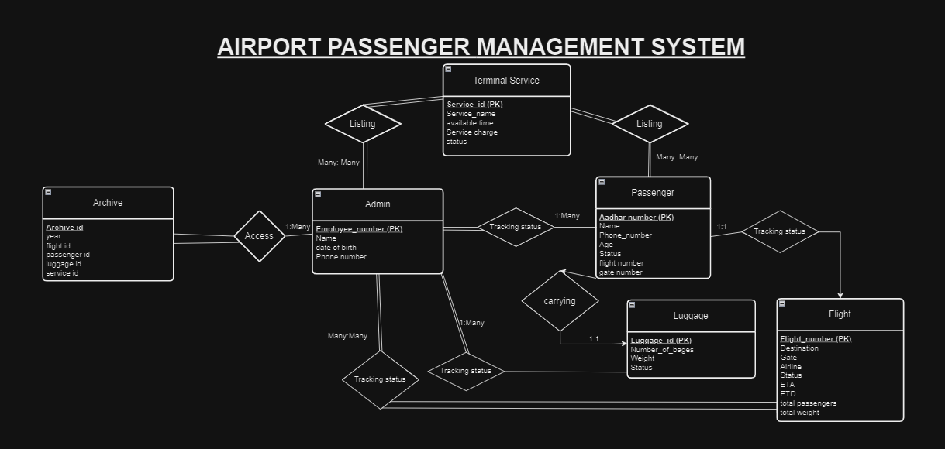

**Extended ER Diagram:**

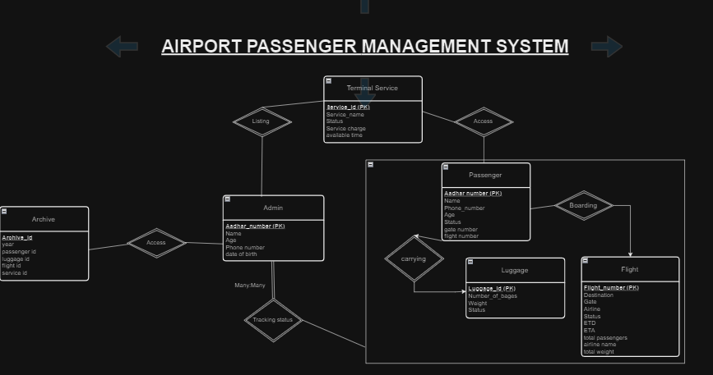

**Schema Diagram:**

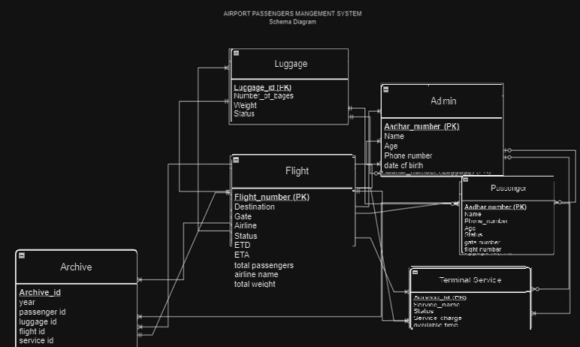

**Relational Schema:**

**Relational Schema**

**1. Terminal_Service**

* **Service_id**: INTEGER PRIMARY KEY AUTOINCREMENT
* **Service_name**: TEXT
* **Service_charges**: REAL
* **Available_time**: TEXT
* **Status**: TEXT

**2. Admin**

* **Employee_number**: TEXT PRIMARY KEY
* **Name**: TEXT
* **Date_of_birth**: TEXT
* **Phone_number**: TEXT

**3. Passenger**

* **Aadhar_number**: TEXT PRIMARY KEY
* **Name**: TEXT
* **Phone_number**: TEXT
* **Age**: INTEGER
* **Gate_number**: TEXT

**4. Luggage**

* **Luggage_id**: INTEGER PRIMARY KEY AUTOINCREMENT
* **Aadhar_number**: TEXT
  + FOREIGN KEY (Aadhar_number) REFERENCES Passenger(Aadhar_number)
* **Number_of_bags**: INTEGER
* **Total_weight**: REAL
* **Status**: TEXT

**5. Flight**

* **Flight_number**: TEXT PRIMARY KEY
* **Airline_name**: TEXT
* **Aeroplane_model**: TEXT
* **Total_passengers**: INTEGER
* **Total_weight**: REAL
* **Gate_number**: TEXT
* **ETA**: TEXT
* **ETD**: TEXT
* **Date**: TEXT
* **Status**: TEXT

**6. Passenger_Flight**

* **Aadhar_number**: TEXT
  + FOREIGN KEY (Aadhar_number) REFERENCES Passenger(Aadhar_number)
* **Flight_number**: TEXT
  + FOREIGN KEY (Flight_number) REFERENCES Flight(Flight_number)
* PRIMARY KEY (Aadhar_number, Flight_number)

**7. Archive**

* **Archive_ID**: INTEGER PRIMARY KEY AUTOINCREMENT
* **Passenger_ID**: TEXT
  + FOREIGN KEY (Passenger_ID) REFERENCES Passenger(Aadhar_number)
* **Luggage_ID**: INTEGER
  + FOREIGN KEY (Luggage_ID) REFERENCES Luggage(Luggage_id)
* **Service_ID**: INTEGER
  + FOREIGN KEY (Service_ID) REFERENCES Terminal_Service(Service_id)
* **Flight_ID**: TEXT
  + FOREIGN KEY (Flight_ID) REFERENCES Flight(Flight_number)
* **Year**: INTEGER

**Explanation**

1. **Terminal_Service**: This table stores information about the services available at the terminal, such as cleaning, catering, security, etc.
2. **Admin**: This table contains information about the admin employees, including their employee number, name, date of birth, phone number, and the service they are responsible for.
3. **Passenger**: This table holds passenger information, including their Aadhar number, name, phone number, age, and gate number.
4. **Luggage**: This table stores luggage information linked to passengers, including luggage ID, Aadhar number, number of bags, total weight, and status.
5. **Flight**: This table contains flight information, including flight number, airline name, aeroplane model, total passengers, total weight, gate number, ETA, ETD, date, and status.
6. **Passenger_Flight**: This table links passengers to flights they are taking. It is a many-to-many relationship between Passenger and Flight.
7. **Archive**: This table stores archived information linking passengers, luggage, services, and flights along with the year. It references primary keys from Passenger, Luggage, Terminal_Service, and Flight.

**Insert appropriate data into the tables and generate 10 queries.**

**The queries must be based on the following:**

i. Aggregate functions, Group by…having

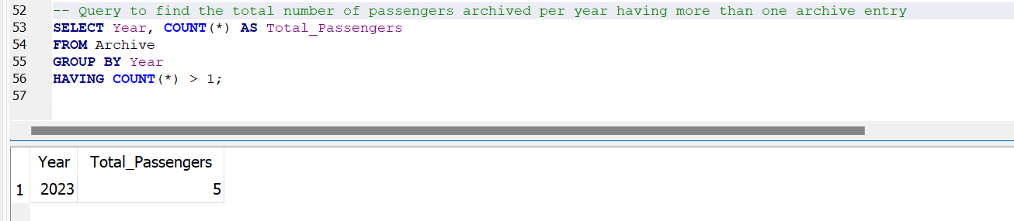

ii. Order by

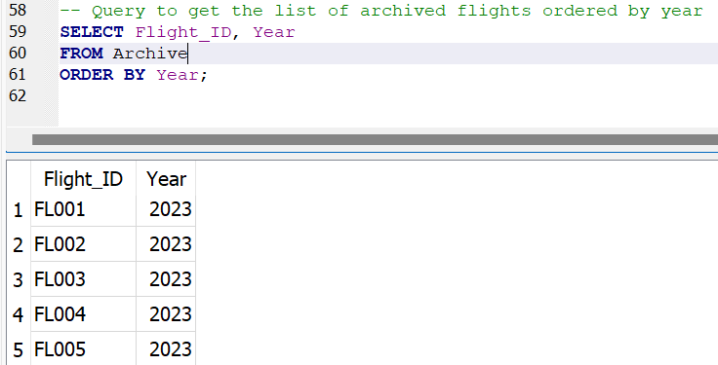

iii. Join, Outer Join

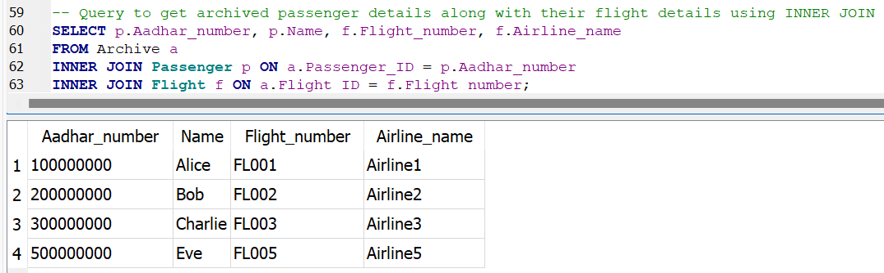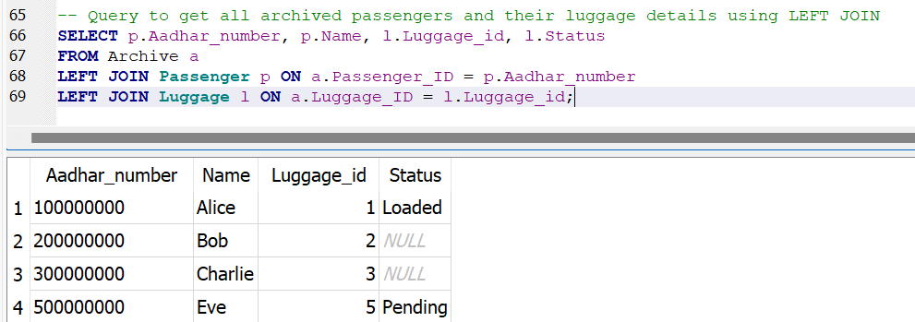

iv. Query having Boolean operators

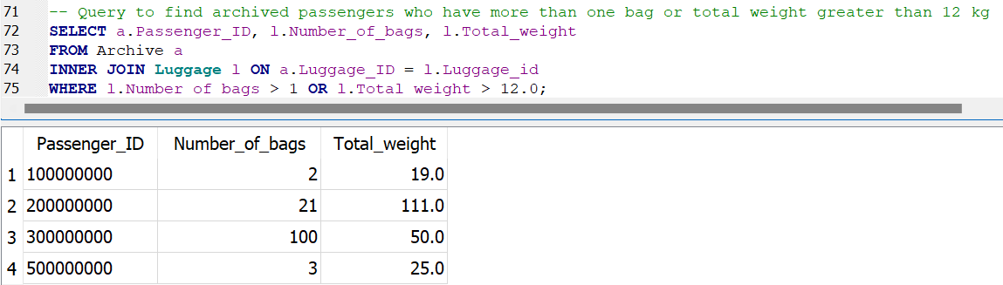

v. Query having arithmetic operators

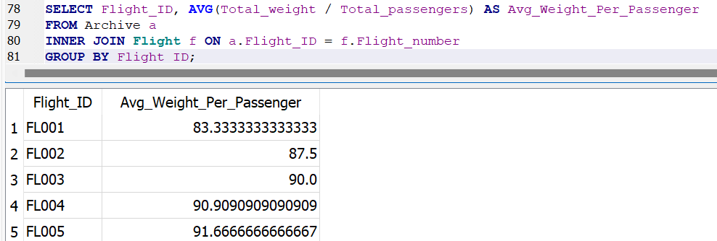

vi. A search query using string operators

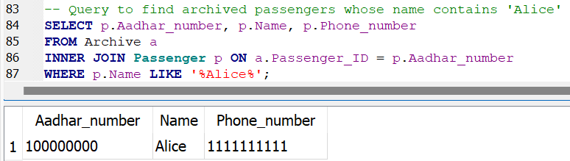

vii. Usage of to_char, extract

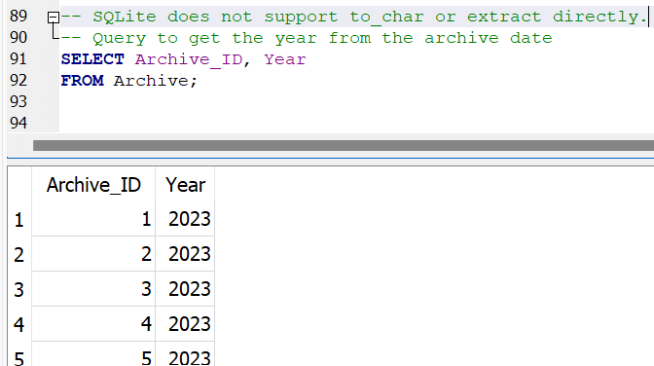

viii. Between, IN, Not between, Not IN

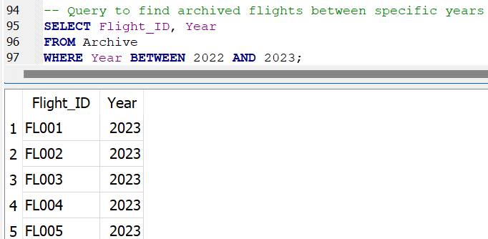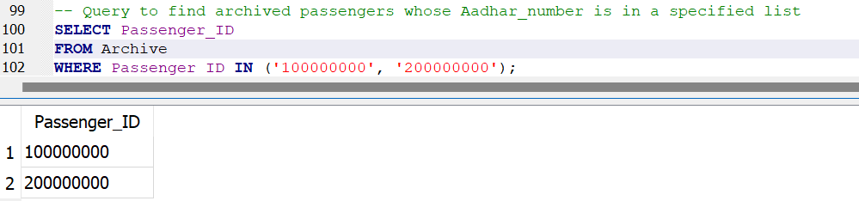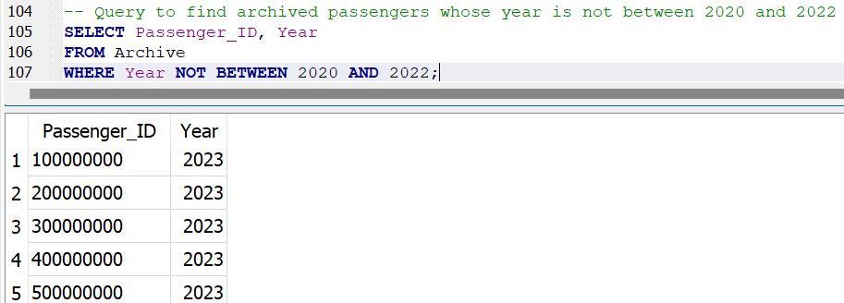

ix. Set operations

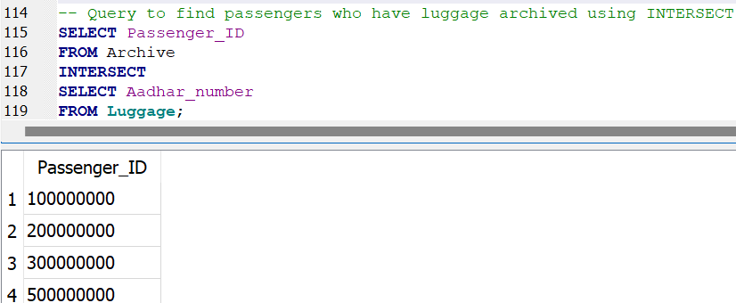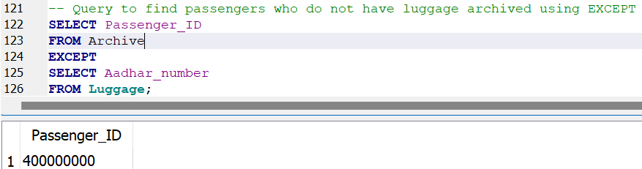

x. Subquery using EXISTS / NOT EXISTS, ANY, AL

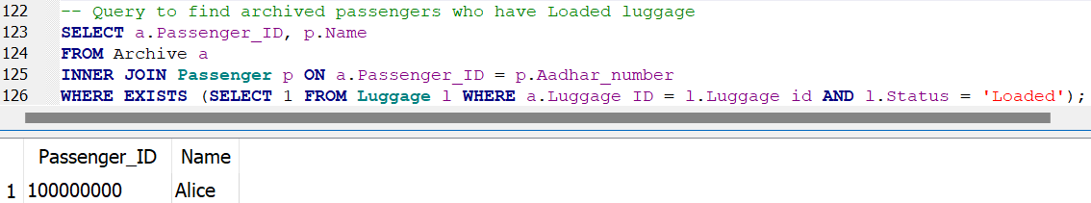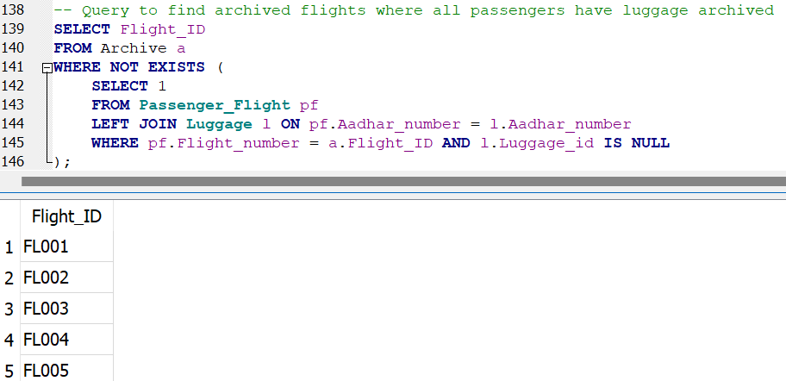

**Construct a universal table related to your assigned project. The table should consist of at least 12 attributes.**

**Normalization (1NF - 3NF):**

**Universal table and 1NF**

Record_ID | Passenger_Aadhar | Passenger_Name | Passenger_Phone | Passenger_Age | Gate_Number | Flight_Number | Airline_Name | Flight_Status | Luggage_ID | Number_of_Bags | Luggage_Weight | Luggage_Status | Service_ID | Service_Name | Admin_ID | Admin_Name | Year

**2NF**

**Passenger** Table

Passenger_Aadhar | Passenger_Name | Passenger_Phone | Passenger_Age I Gate number

**Flight** Table

Flight_Number | Airline_Name | Flight_Status I Gate number

**Luggage** Table

Luggage_ID | Number_of_Bags | Luggage_Weight | Luggage_Status I Gate number

**Service** Table

Service_ID | Service_Name

**Admin** Table

Admin_ID | Admin_Name

**Archive** Table

Record_ID | Year

**3NF**

**Passenger** Table

Passenger_Aadhar | Passenger_Name | Passenger_Phone | Passenger_Age I Gate number

**Flight** Table

Flight_Number | Airline_Name | Flight_Status I Gate number

**Luggage** Table

Luggage_ID | Number_of_Bags | Luggage_Weight | Luggage_Status I Gate number

**Service** Table

Service_ID | Service_Name

**Admin** Table

Admin_ID | Admin_Name

**Archive** Table

Record_ID | Year

**Screenshots:**

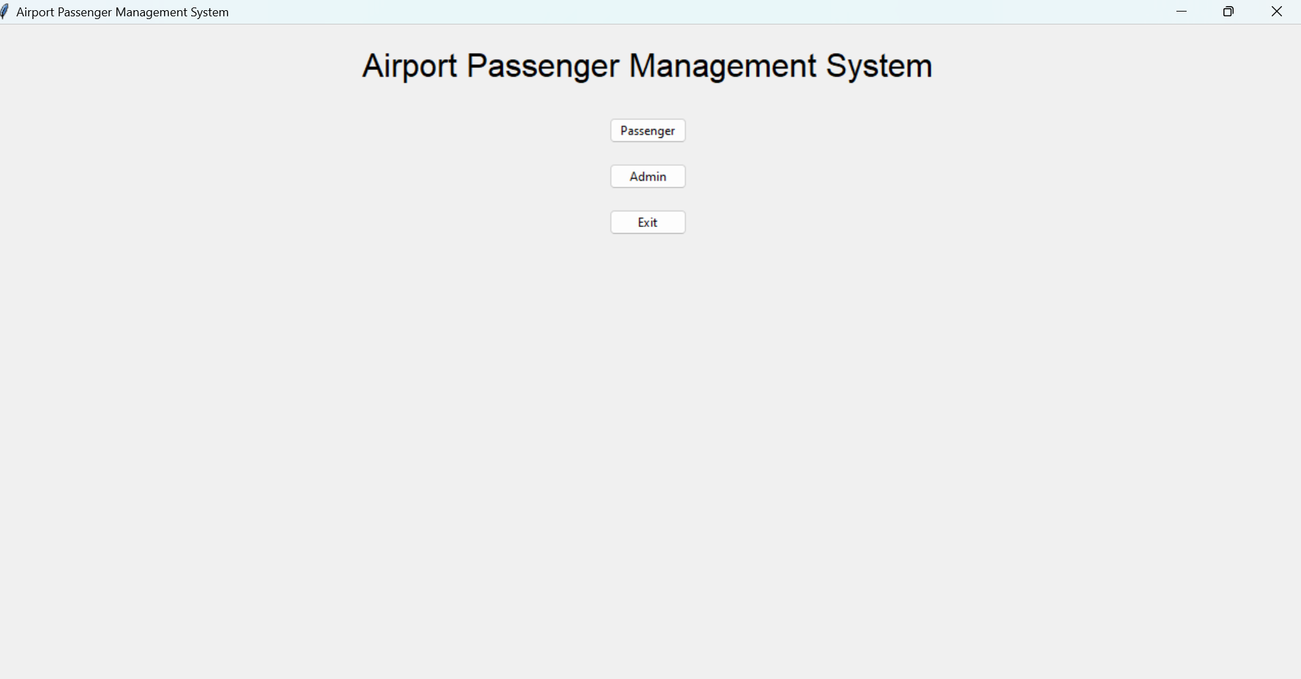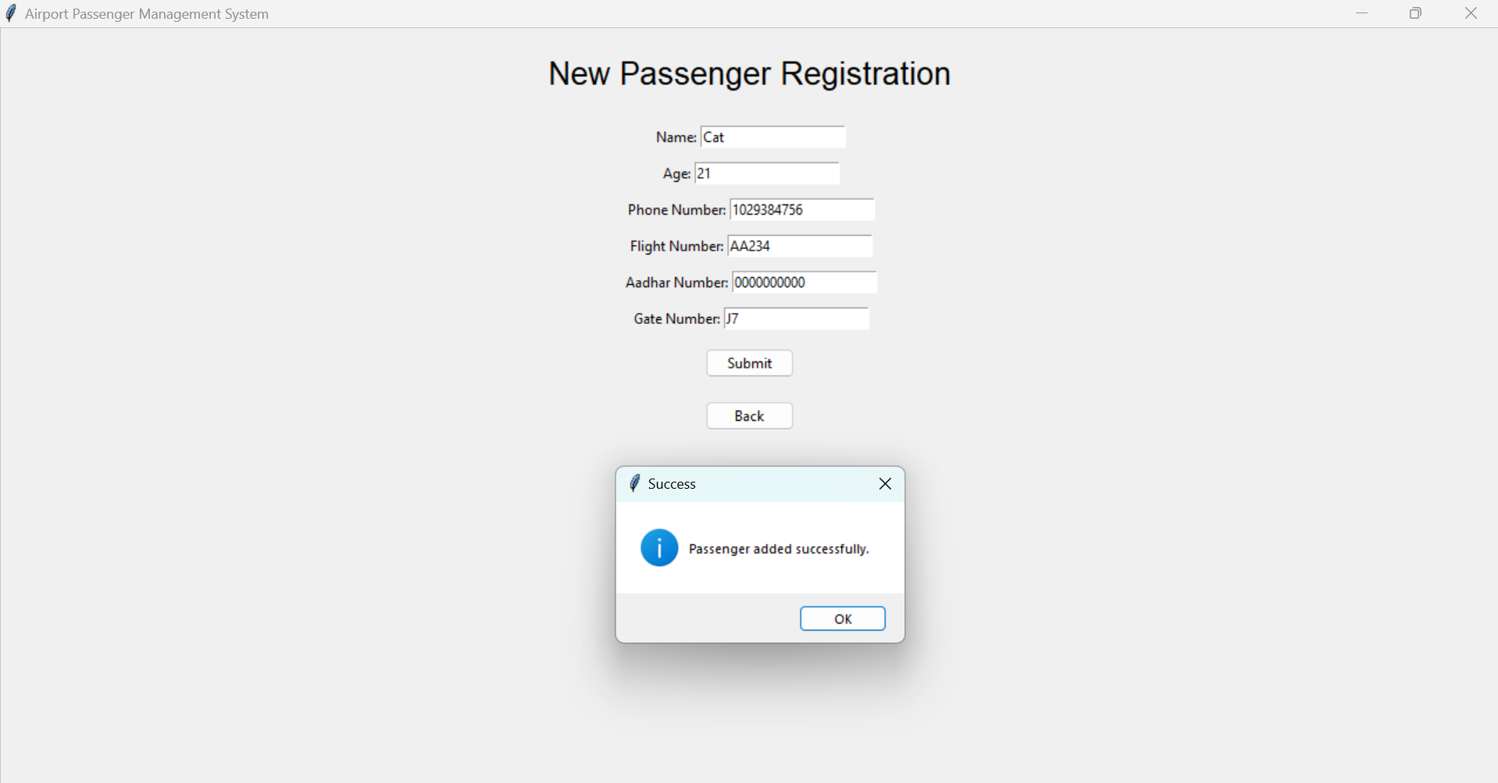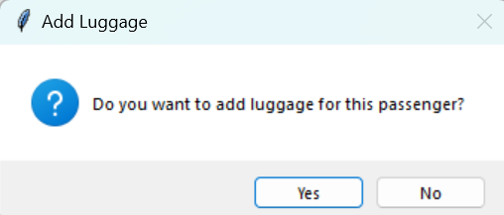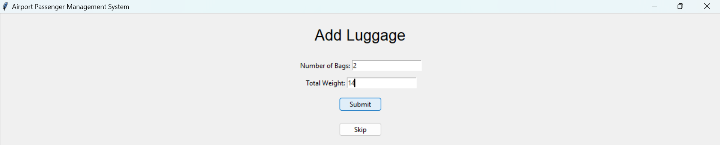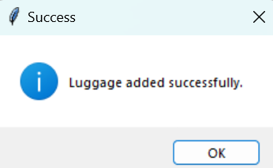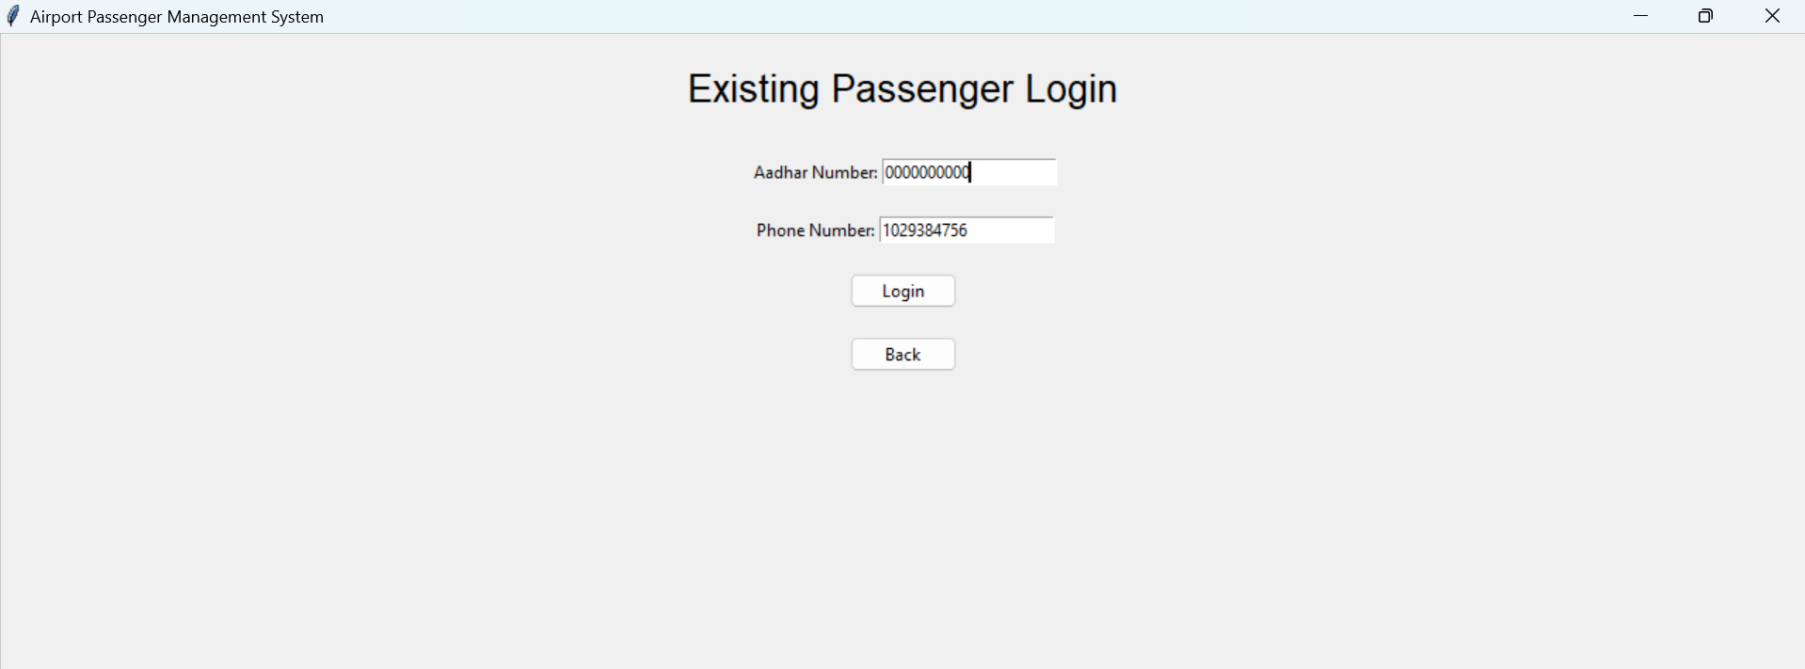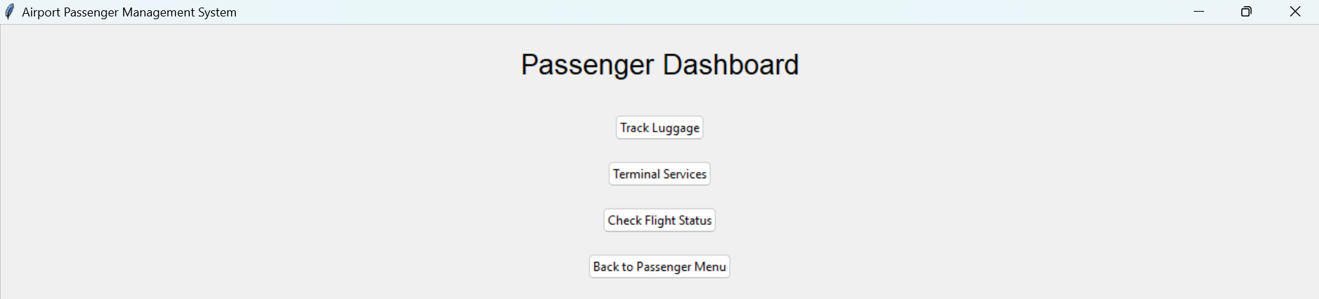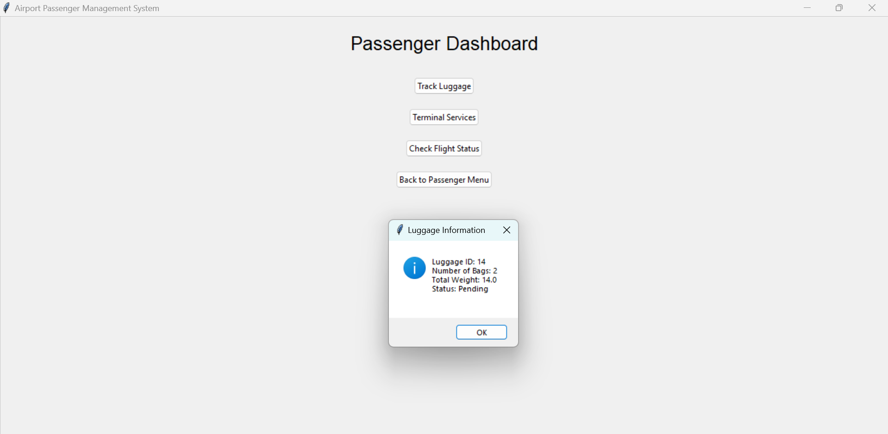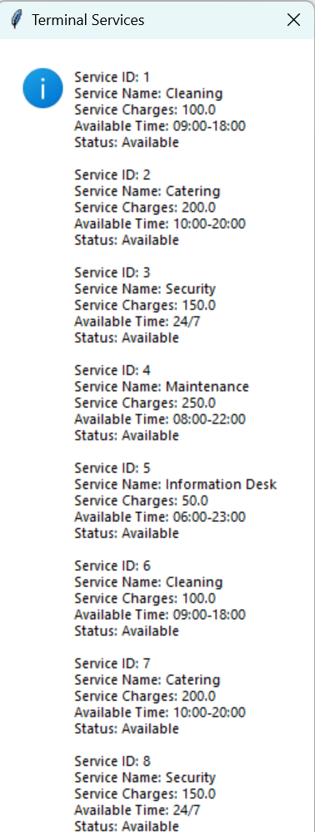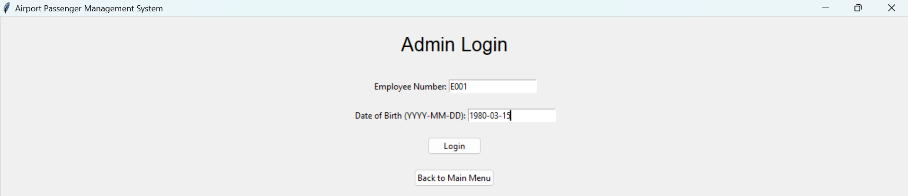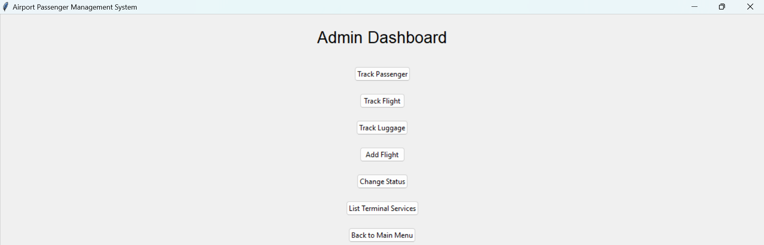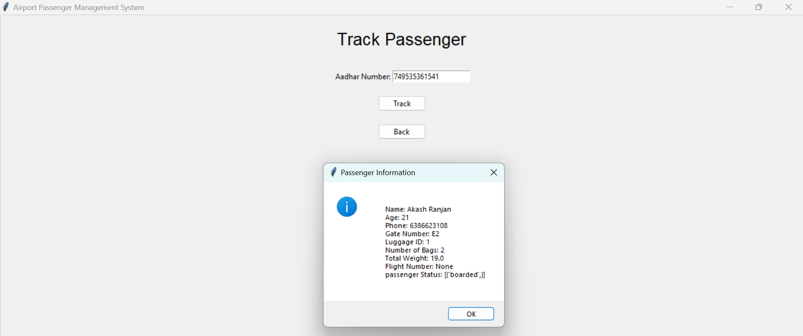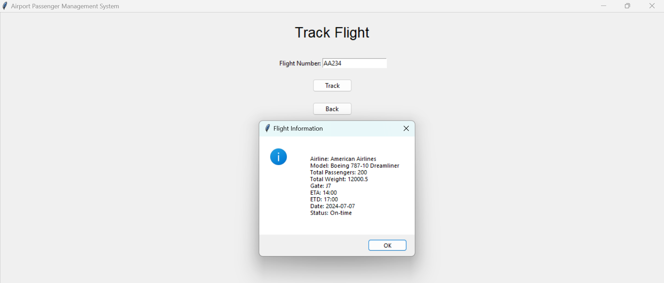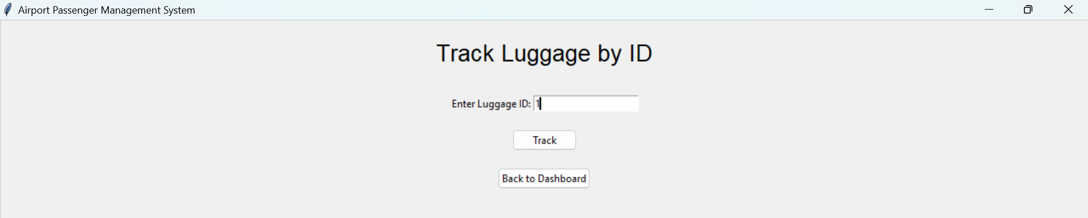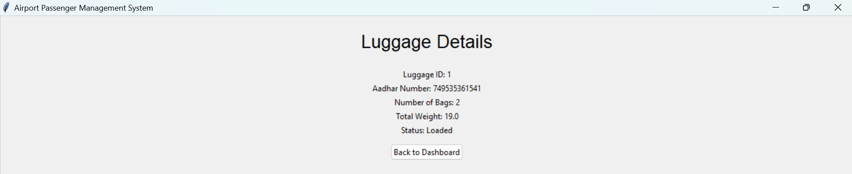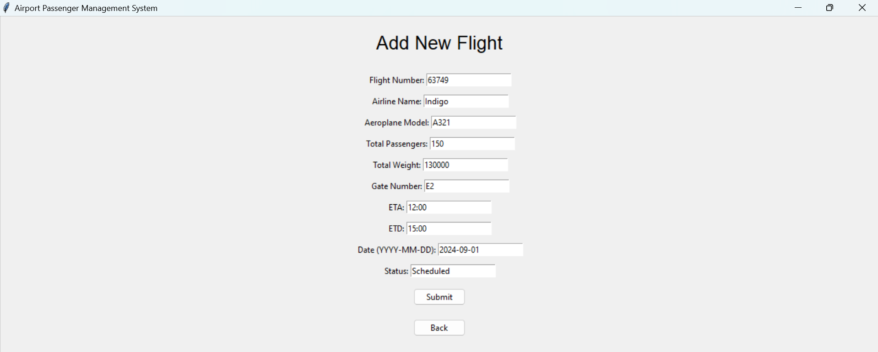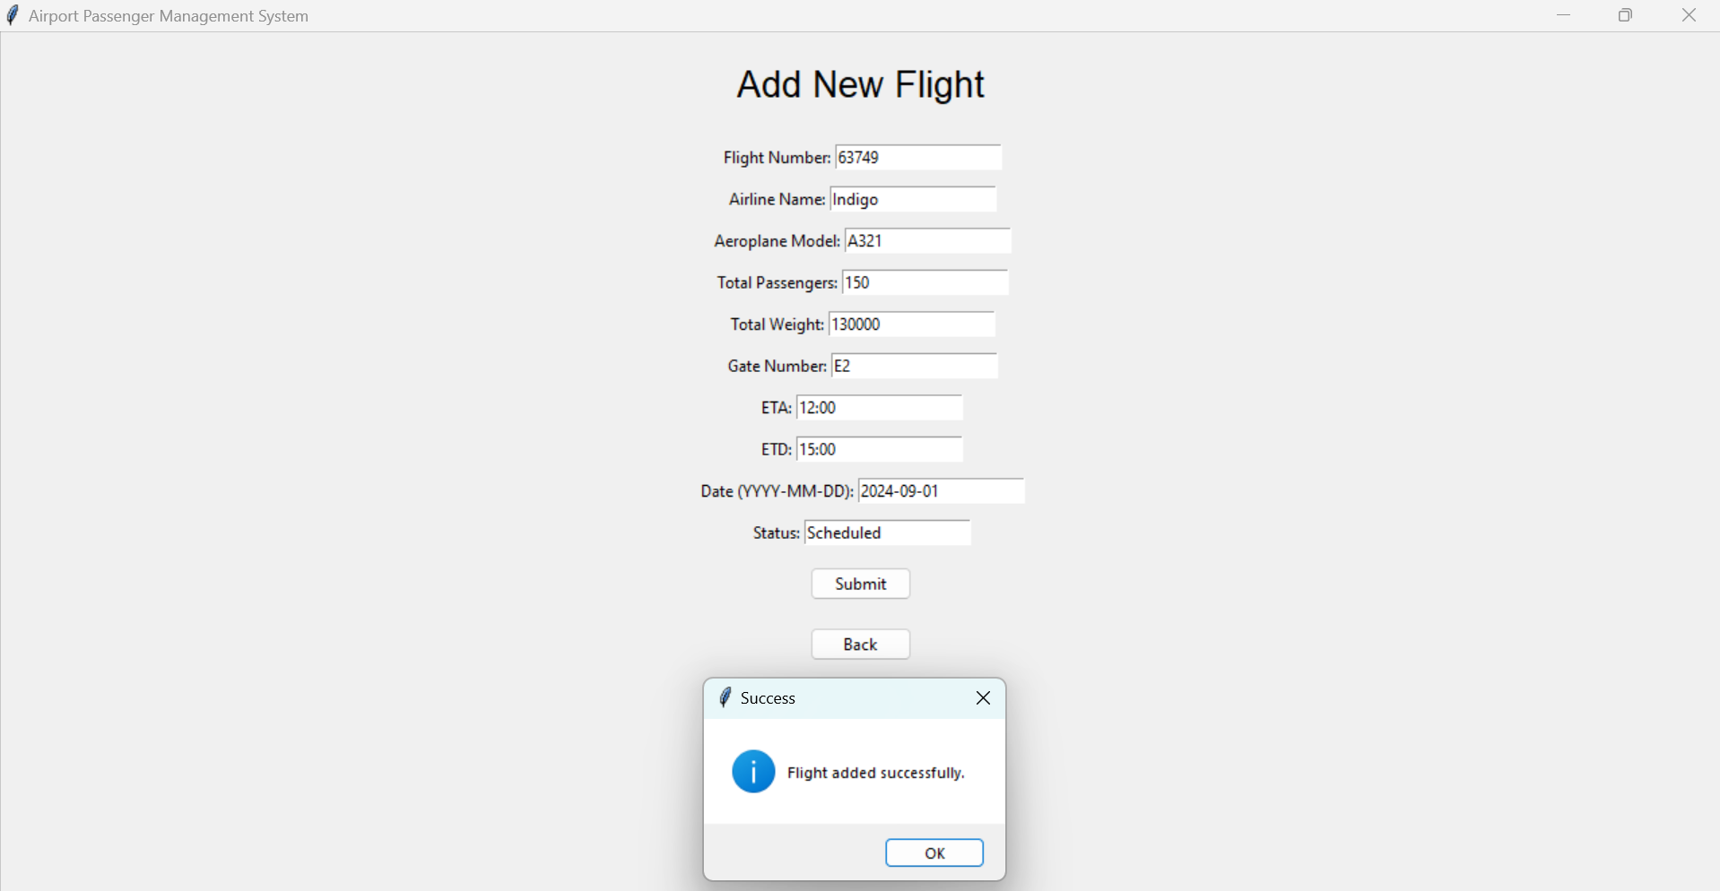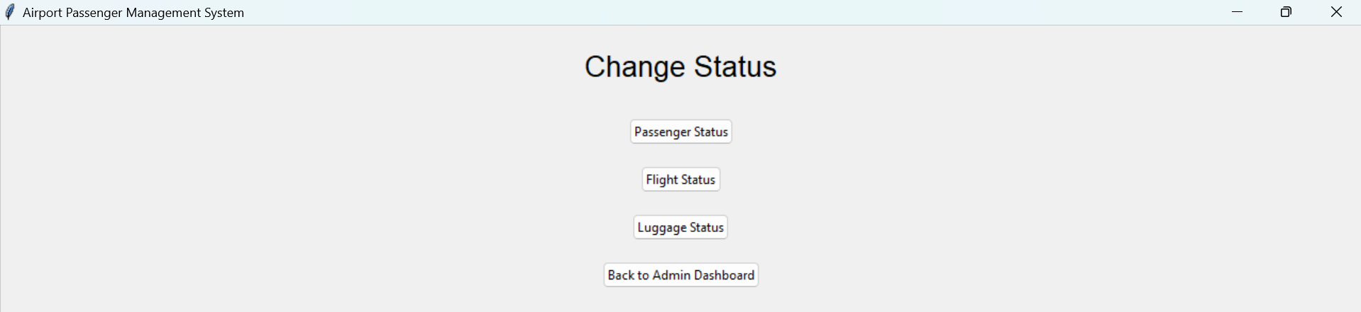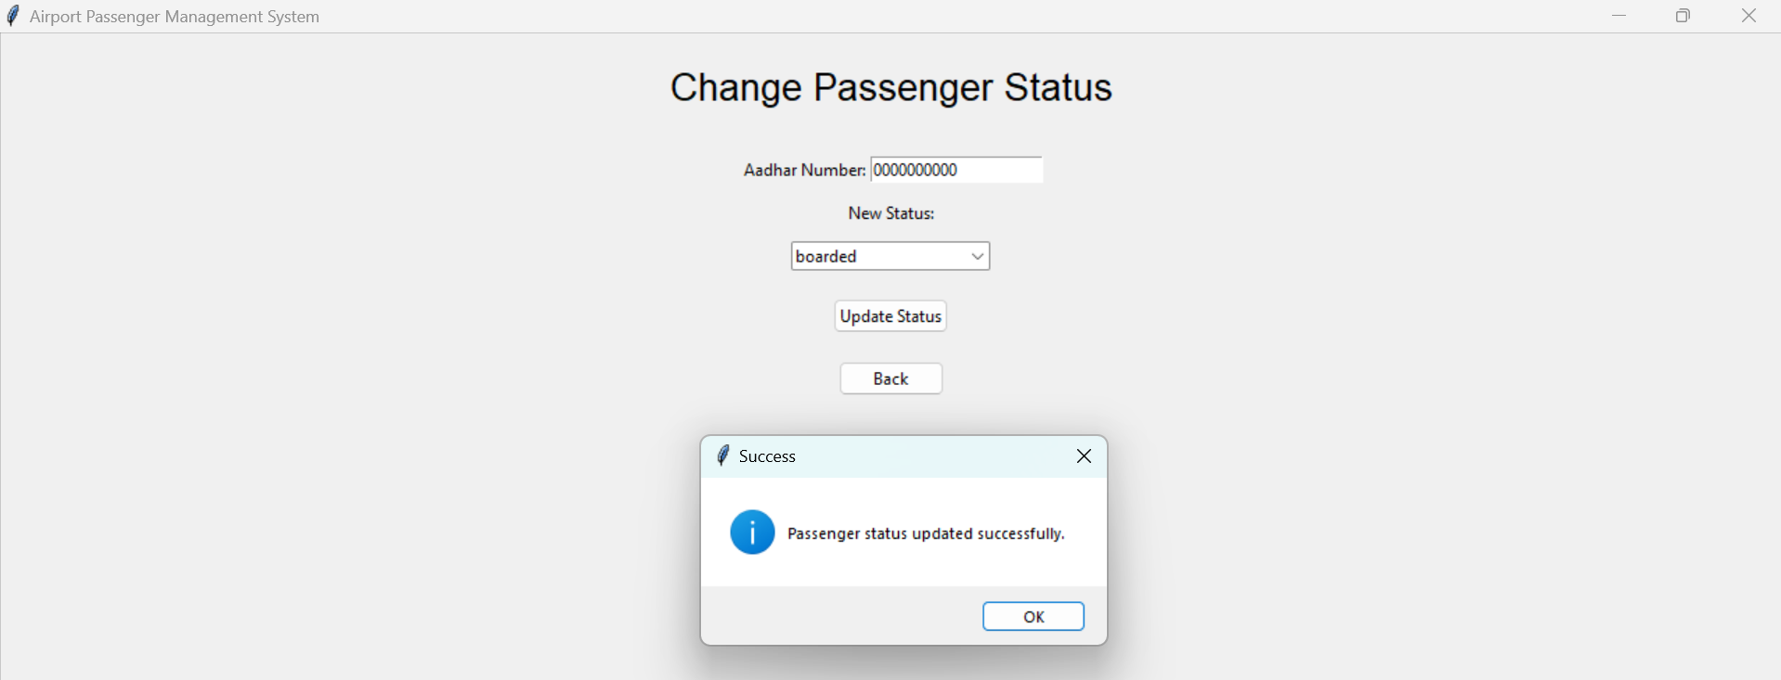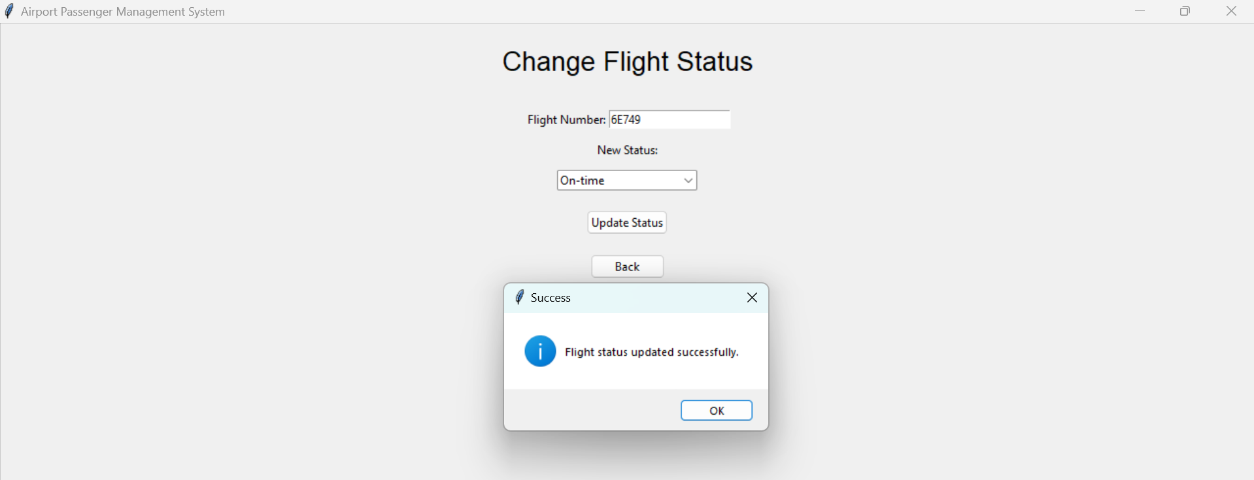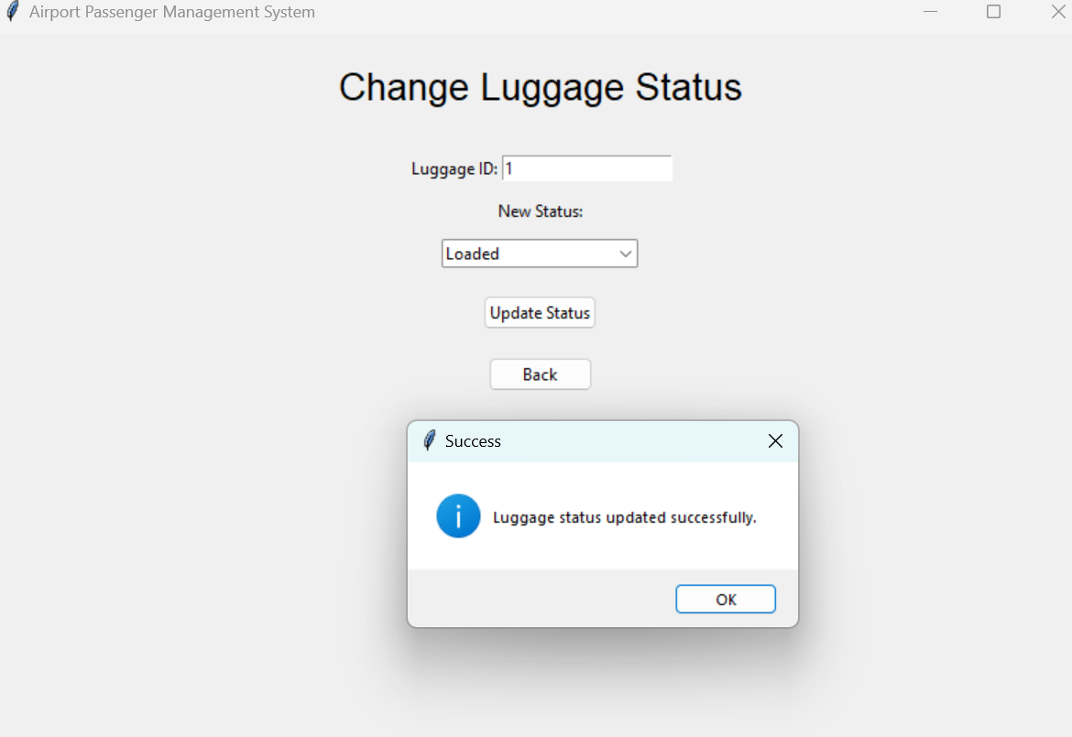

**CODE:**

import tkinter as tk

from tkinter import ttk, messagebox

import sqlite3

from datetime import datetime

DB_FILE = 'airport_management.db'

def connect_db():

    return sqlite3.connect(DB_FILE)

def execute_query(query, params=None):

    with connect_db() as conn:

        cur = conn.cursor()

        if params:

            cur.execute(query, params)

        else:

            cur.execute(query)

        conn.commit()

        return cur.fetchall()

def create_tables():

    queries = [

        """

        CREATE TABLE IF NOT EXISTS Terminal_Service (

            Service_id INTEGER PRIMARY KEY AUTOINCREMENT,

            Service_name TEXT,

            Service_charges REAL,

            Available_time TEXT,

            Status TEXT

        )

        """,

        """

        CREATE TABLE IF NOT EXISTS Admin (

            Employee_number TEXT PRIMARY KEY,

            Name TEXT,

            Date_of_birth TEXT,

            Phone_number TEXT,

            Service_id INTEGER,

            FOREIGN KEY (Service_id) REFERENCES Terminal_Service(Service_id)

        )

        """,

        """

        CREATE TABLE IF NOT EXISTS Passenger (

            Aadhar_number TEXT PRIMARY KEY,

            Name TEXT,

            Phone_number TEXT,

            Age INTEGER,

            Gate_number TEXT

        )

        """,

        """

        CREATE TABLE IF NOT EXISTS Luggage (

            Luggage_id INTEGER PRIMARY KEY AUTOINCREMENT,

            Aadhar_number TEXT,

            Number_of_bags INTEGER,

            Total_weight REAL,

            Status TEXT,

            FOREIGN KEY (Aadhar_number) REFERENCES Passenger(Aadhar_number)

        )

        """,

        """

        CREATE TABLE IF NOT EXISTS Flight (

            Flight_number TEXT PRIMARY KEY,

            Airline_name TEXT,

            Aeroplane_model TEXT,

            Total_passengers INTEGER,

            Total_weight REAL,

            Gate_number TEXT,

            ETA TEXT,

            ETD TEXT,

            Date TEXT,

            Status TEXT

        )

        """,

        """

        CREATE TABLE IF NOT EXISTS Passenger_Flight (

            Aadhar_number TEXT,

            Flight_number TEXT,

            PRIMARY KEY (Aadhar_number, Flight_number),

            FOREIGN KEY (Aadhar_number) REFERENCES Passenger(Aadhar_number),

            FOREIGN KEY (Flight_number) REFERENCES Flight(Flight_number)

        )

        """

    ]

    for query in queries:

        execute_query(query)

def fill_archive_table():

    year = datetime.now().year

    archive_data_queries = [

        """

        INSERT INTO Archive (Passenger_ID, Luggage_ID, Service_ID, Flight_ID, Year)

        SELECT p.Aadhar_number, l.Luggage_id, a.Service_id, pf.Flight_number, ?

        FROM Passenger p

        LEFT JOIN Luggage l ON p.Aadhar_number = l.Aadhar_number

        LEFT JOIN Passenger_Flight pf ON p.Aadhar_number = pf.Aadhar_number

        LEFT JOIN Admin a ON a.Service_id = (SELECT Service_id FROM Terminal_Service ORDER BY RANDOM() LIMIT 1)

        """

    ]

    for query in archive_data_queries:

        execute_query(query, (year,))

class AirportManagementSystem:

    def __init__(self, master):

        self.master = master

        self.master.title("Airport Passenger Management System")

        self.master.geometry("800x600")

        self.create_main_menu()

    def create_main_menu(self):

        self.clear_window()

        tk.Label(self.master, text="Airport Passenger Management System", font=("Arial", 24)).pack(pady=20)

        ttk.Button(self.master, text="Passenger", command=self.passenger_menu).pack(pady=10)

        ttk.Button(self.master, text="Admin", command=self.admin_login).pack(pady=10)

        ttk.Button(self.master, text="Exit", command=self.master.quit).pack(pady=10)

    def clear_window(self):

        for widget in self.master.winfo_children():

            widget.destroy()

    def passenger_menu(self):

        self.clear_window()

        tk.Label(self.master, text="Passenger Menu", font=("Arial", 20)).pack(pady=20)

        ttk.Button(self.master, text="New Passenger", command=self.new_passenger_form).pack(pady=10)

        ttk.Button(self.master, text="Existing Passenger", command=self.existing_passenger_login).pack(pady=10)

        ttk.Button(self.master, text="Back to Main Menu", command=self.create_main_menu).pack(pady=10)

    def new_passenger_form(self):

        self.clear_window()

        tk.Label(self.master, text="New Passenger Registration", font=("Arial", 20)).pack(pady=20)

        fields = ['Name', 'Age', 'Phone Number', 'Flight Number', 'Aadhar Number', 'Gate Number']

        entries = {}

        for field in fields:

            frame = tk.Frame(self.master)

            frame.pack(pady=5)

            tk.Label(frame, text=f"{field}:").pack(side=tk.LEFT)

            entry = tk.Entry(frame)

            entry.pack(side=tk.LEFT)

            entries[field] = entry

        ttk.Button(self.master, text="Submit", command=lambda: self.add_new_passenger(entries)).pack(pady=10)

        ttk.Button(self.master, text="Back", command=self.passenger_menu).pack(pady=10)

    def add_new_passenger(self, entries):

        # Extract values from entries

        name = entries['Name'].get()

        age = entries['Age'].get()

        phone = entries['Phone Number'].get()

        flight_number = entries['Flight Number'].get()

        aadhar = entries['Aadhar Number'].get()

        gate = entries['Gate Number'].get()

        # Perform validation here

        if not all([name, age, phone, flight_number, aadhar, gate]):

            messagebox.showerror("Error", "Please fill in all fields.")

            return

        query = """

        INSERT INTO Passenger (Aadhar_number, Name, Phone_number, Age, Gate_number)

        VALUES (?, ?, ?, ?, ?)

        """

        execute_query(query, (aadhar, name, phone, age, gate))

        query = """

        INSERT INTO Passenger_Flight (Aadhar_number, Flight_number)

        VALUES (?, ?)

        """

        execute_query(query, (aadhar, flight_number))

        messagebox.showinfo("Success", "Passenger added successfully.")

        # Ask if user wants to add luggage

        if messagebox.askyesno("Add Luggage", "Do you want to add luggage for this passenger?"):

            self.add_luggage_form(aadhar)

        else:

            self.passenger_menu()

    def add_luggage_form(self, aadhar):

        self.clear_window()

        tk.Label(self.master, text="Add Luggage", font=("Arial", 20)).pack(pady=20)

        fields = ['Number of Bags', 'Total Weight']

        entries = {}

        for field in fields:

            frame = tk.Frame(self.master)

            frame.pack(pady=5)

            tk.Label(frame, text=f"{field}:").pack(side=tk.LEFT)

            entry = tk.Entry(frame)

            entry.pack(side=tk.LEFT)

            entries[field] = entry

        ttk.Button(self.master, text="Submit", command=lambda: self.add_new_luggage(aadhar, entries)).pack(pady=10)

        ttk.Button(self.master, text="Skip", command=self.passenger_menu).pack(pady=10)

    def add_new_luggage(self, aadhar, entries):

        # Extract values from entries

        num_bags = entries['Number of Bags'].get()

        total_weight = entries['Total Weight'].get()

        # Perform validation here

        if not all([num_bags, total_weight]):

            messagebox.showerror("Error", "Please fill in all fields.")

            return

        query = """

        INSERT INTO Luggage (Aadhar_number, Number_of_bags, Total_weight, Status)

        VALUES (?, ?, ?, ?)

        """

        execute_query(query, (aadhar, num_bags, total_weight, "Pending"))

        messagebox.showinfo("Success", "Luggage added successfully.")

        self.passenger_menu()

    def existing_passenger_login(self):

        self.clear_window()

        tk.Label(self.master, text="Existing Passenger Login", font=("Arial", 20)).pack(pady=20)

        frame = tk.Frame(self.master)

        frame.pack(pady=10)

        tk.Label(frame, text="Aadhar Number:").pack(side=tk.LEFT)

        aadhar_entry = tk.Entry(frame)

        aadhar_entry.pack(side=tk.LEFT)

        frame = tk.Frame(self.master)

        frame.pack(pady=10)

        tk.Label(frame, text="Phone Number:").pack(side=tk.LEFT)

        phone_entry = tk.Entry(frame)

        phone_entry.pack(side=tk.LEFT)

        ttk.Button(self.master, text="Login", command=lambda: self.authenticate_passenger(aadhar_entry.get(), phone_entry.get())).pack(pady=10)

        ttk.Button(self.master, text="Back", command=self.passenger_menu).pack(pady=10)

    def authenticate_passenger(self, aadhar, phone):

        query = """

        SELECT * FROM Passenger WHERE Aadhar_number = ? AND Phone_number = ?

        """

        result = execute_query(query, (aadhar, phone))

        if result:

            self.passenger_dashboard(aadhar)

        else:

            messagebox.showerror("Error", "Authentication failed.")

    def passenger_dashboard(self, aadhar):

        self.clear_window()

        tk.Label(self.master, text="Passenger Dashboard", font=("Arial", 20)).pack(pady=20)

        ttk.Button(self.master, text="Track Luggage", command=lambda: self.track_luggage(aadhar)).pack(pady=10)

        ttk.Button(self.master, text="Terminal Services", command=self.show_terminal_services).pack(pady=10)

        ttk.Button(self.master, text="Check Flight Status", command=lambda: self.check_flight_status(aadhar)).pack(pady=10)

        ttk.Button(self.master, text="Back to Passenger Menu", command=self.passenger_menu).pack(pady=10)

    def track_luggage(self, aadhar):

        query = """

        SELECT * FROM Luggage WHERE Aadhar_number = ?

        """

        result = execute_query(query, (aadhar,))

        if result:

            luggage_info = ""

            for luggage in result:

                luggage_info += f"Luggage ID: {luggage[0]}\n"

                luggage_info += f"Number of Bags: {luggage[2]}\n"

                luggage_info += f"Total Weight: {luggage[3]}\n"

                luggage_info += f"Status: {luggage[4]}\n\n"

            messagebox.showinfo("Luggage Information", luggage_info)

        else:

            messagebox.showinfo("Luggage Information", "No luggage found for this passenger.")

    def check_flight_status(self, aadhar):

        query = """

        SELECT f.Flight_number, fs.Status

        FROM Passenger_Flight pf

        JOIN Flight f ON f.Flight_number = pf.Flight_number

        JOIN flight_status fs ON pf.Flight_number = fs.Status

        WHERE pf.aadhar_number = ?

        """

        result = execute_query(query, (aadhar,))

        if result:

            flight_info = ""

            for flight in result:

                flight_info += f"Flight Number: {flight[0]}\n"

                flight_info += f"Status: {flight[1]}\n\n"

            messagebox.showinfo("Flight Information", flight_info)

        else:

            messagebox.showinfo("Flight Information", "No flight information found for this passenger.")

    def admin_login(self):

        self.clear_window()

        tk.Label(self.master, text="Admin Login", font=("Arial", 20)).pack(pady=20)

        frame = tk.Frame(self.master)

        frame.pack(pady=10)

        tk.Label(frame, text="Employee Number:").pack(side=tk.LEFT)

        emp_num_entry = tk.Entry(frame)

        emp_num_entry.pack(side=tk.LEFT)

        frame = tk.Frame(self.master)

        frame.pack(pady=10)

        tk.Label(frame, text="Date of Birth (YYYY-MM-DD):").pack(side=tk.LEFT)

        dob_entry = tk.Entry(frame)

        dob_entry.pack(side=tk.LEFT)

        ttk.Button(self.master, text="Login", command=lambda: self.authenticate_admin(emp_num_entry.get(), dob_entry.get())).pack(pady=10)

        ttk.Button(self.master, text="Back to Main Menu", command=self.create_main_menu).pack(pady=10)

    def authenticate_admin(self, emp_num, dob):

        query = """

        SELECT * FROM Admin WHERE Employee_number = ? AND Date_of_birth = ?

        """

        result = execute_query(query, (emp_num, dob))

        if result:

            self.admin_dashboard()

        else:

            messagebox.showerror("Error", "Authentication failed.")

    def admin_dashboard(self):

        self.clear_window()

        tk.Label(self.master, text="Admin Dashboard", font=("Arial", 20)).pack(pady=20)

        ttk.Button(self.master, text="Track Passenger", command=self.track_passenger_form).pack(pady=10)

        ttk.Button(self.master, text="Track Flight", command=self.track_flight_form).pack(pady=10)

        ttk.Button(self.master, text="Track Luggage", command=self.track_luggage_by_id_form).pack(pady=10)

        ttk.Button(self.master, text="Add Flight", command=self.add_flight_form).pack(pady=10)

        ttk.Button(self.master, text="Change Status", command=self.change_status_menu).pack(pady=10)

        ttk.Button(self.master, text="List Terminal Services", command=self.show_terminal_services).pack(pady=10)

        ttk.Button(self.master, text="Back to Main Menu", command=self.create_main_menu).pack(pady=10)

    def change_status_menu(self):

        self.clear_window()

        tk.Label(self.master, text="Change Status", font=("Arial", 20)).pack(pady=20)

        ttk.Button(self.master, text="Passenger Status", command=lambda: self.change_status_form("passenger")).pack(pady=10)

        ttk.Button(self.master, text="Flight Status", command=lambda: self.change_status_form("flight")).pack(pady=10)

        ttk.Button(self.master, text="Luggage Status", command=lambda: self.change_status_form("luggage")).pack(pady=10)

        ttk.Button(self.master, text="Back to Admin Dashboard", command=self.admin_dashboard).pack(pady=10)

    def change_status_form(self, status_type):

        self.clear_window()

        tk.Label(self.master, text=f"Change {status_type.capitalize()} Status", font=("Arial", 20)).pack(pady=20)

        if status_type == "passenger":

            id_label = "Aadhar Number"

            id_column = "Aadhar_number"

            table = "passenger_status"

            status_table = "set_passenger_status"

        elif status_type == "flight":

            id_label = "Flight Number"

            id_column = "Flight_number"

            table = "Flight_status"

            status_table = "set_flight_status"

        else:  # luggage

            id_label = "Luggage ID"

            id_column = "Luggage_number"

            table = "Luggage_status"

            status_table = "set_luggage_status"

        frame = tk.Frame(self.master)

        frame.pack(pady=10)

        tk.Label(frame, text=f"{id_label}:").pack(side=tk.LEFT)

        id_entry = tk.Entry(frame)

        id_entry.pack(side=tk.LEFT)

        status_options = self.get_status_options(status_table)

        status_var = tk.StringVar(self.master)

        status_var.set(status_options[0])  # Set default value

        tk.Label(self.master, text="New Status:").pack()

        status_menu = ttk.Combobox(self.master, textvariable=status_var, values=status_options)

        status_menu.pack(pady=10)

        ttk.Button(self.master, text="Update Status",

                   command=lambda: self.update_status(status_type, id_entry.get(), status_var.get(), id_column, table)).pack(pady=10)

        ttk.Button(self.master, text="Back", command=self.change_status_menu).pack(pady=10)

    def get_status_options(self, status_table):

        try:

            query = f"SELECT status_name FROM {status_table}"

            result = execute_query(query)

            return [status[0] for status in result] if result else []

        except sqlite3.Error as e:

            print(f"An error occurred: {e}")

            messagebox.showerror("Error", f"Failed to get status options: {e}")

            return []

    def update_status(self, status_type, id_value, new_status, id_column, table):

        if not id_value or not new_status:

            messagebox.showerror("Error", "Please fill in all fields.")

            return

        query = f"UPDATE {table} SET Status = ? WHERE {id_column} = ?"

        execute_query(query, (new_status, id_value))

        if status_type == "passenger":

            # Update or insert into passenger_status table

            check_query = "SELECT * FROM passenger_status WHERE Aadhar_number = ?"

            result = execute_query(check_query, (id_value,))

            if result:

                update_query = "UPDATE passenger_status SET Status = ? WHERE Aadhar_number = ?"

            else:

                update_query = "INSERT INTO passenger_status (Status, Aadhar_number) VALUES (?, ?)"

            execute_query(update_query, (new_status, id_value))

        messagebox.showinfo("Success", f"{status_type.capitalize()} status updated successfully.")

        self.change_status_menu()

    def track_passenger_form(self):

        self.clear_window()

        tk.Label(self.master, text="Track Passenger", font=("Arial", 20)).pack(pady=20)

        frame = tk.Frame(self.master)

        frame.pack(pady=10)

        tk.Label(frame, text="Aadhar Number:").pack(side=tk.LEFT)

        aadhar_entry = tk.Entry(frame)

        aadhar_entry.pack(side=tk.LEFT)

        ttk.Button(self.master, text="Track", command=lambda: self.track_passenger(aadhar_entry.get())).pack(pady=10)

        ttk.Button(self.master, text="Back", command=self.admin_dashboard).pack(pady=10)

    def track_passenger(self, aadhar):

        query = """

        SELECT p.*, l.Luggage_id, l.Number_of_bags, l.Total_weight, l.Status, f.Flight_number, fs.Status

        FROM Passenger p

        LEFT JOIN Luggage l ON p.Aadhar_number = l.Aadhar_number

        LEFT JOIN Passenger_Flight pf ON p.Aadhar_number = pf.Aadhar_number

        LEFT JOIN Flight f ON pf.Flight_number = f.Flight_number

        LEFT JOIN passenger_status fs ON pf.Aadhar_number=fs.Aadhar_number

        WHERE p.Aadhar_number = ?

        """

        result = execute_query(query, (aadhar,))

        query1 = """SELECT Status FROM passenger_status WHERE Aadhar_number= ?"""

        result1=execute_query(query1, (aadhar,))

        if result:

            passenger_info = f"""

            Name: {result[0][1]}

            Age: {result[0][3]}

            Phone: {result[0][2]}

            Gate Number: {result[0][4]}

            Luggage ID: {result[0][5]}

            Number of Bags: {result[0][6]}

            Total Weight: {result[0][7]}

            Flight Number: {result[0][9]}

            passenger Status: {result1}

            """

            messagebox.showinfo("Passenger Information", passenger_info)

        else:

            messagebox.showinfo("Passenger Information", "Passenger not found.")

    def track_flight_form(self):

        self.clear_window()

        tk.Label(self.master, text="Track Flight", font=("Arial", 20)).pack(pady=20)

        frame = tk.Frame(self.master)

        frame.pack(pady=10)

        tk.Label(frame, text="Flight Number:").pack(side=tk.LEFT)

        flight_entry = tk.Entry(frame)

        flight_entry.pack(side=tk.LEFT)

        ttk.Button(self.master, text="Track", command=lambda: self.track_flight(flight_entry.get())).pack(pady=10)

        ttk.Button(self.master, text="Back", command=self.admin_dashboard).pack(pady=10)

    def track_flight(self, flight_num):

        query = "SELECT * FROM Flight WHERE Flight_number = ?"

        query1 = "SELECT Status FROM flight_status WHERE Flight_number = ?"

        result = execute_query(query, (flight_num,))

        stats = execute_query(query1, (flight_num,))

        if stats:

            stats=stats

        else:

            stats = result[0][9]

        if result:

            flight_info = f"""

            Airline: {result[0][1]}

            Model: {result[0][2]}

            Total Passengers: {result[0][3]}

            Total Weight: {result[0][4]}

            Gate: {result[0][5]}

            ETA: {result[0][6]}

            ETD: {result[0][7]}

            Date: {result[0][8]}

            Status: {stats}

            """

            messagebox.showinfo("Flight Information", flight_info)

        else:

            messagebox.showinfo("Flight Information", "Flight not found.")

    def track_luggage_by_id_form(self):

        self.clear_window()

        tk.Label(self.master, text="Track Luggage by ID", font=("Arial", 20)).pack(pady=20)

        frame = tk.Frame(self.master)

        frame.pack(pady=10)

        tk.Label(frame, text="Enter Luggage ID:").pack(side=tk.LEFT)

        luggage_id_entry = tk.Entry(frame)

        luggage_id_entry.pack(side=tk.LEFT)

        ttk.Button(self.master, text="Track", command=lambda: self.track_luggage_by_id(luggage_id_entry.get())).pack(pady=10)

        ttk.Button(self.master, text="Back to Dashboard", command=self.admin_dashboard).pack(pady=10)

    def track_luggage_by_id(self, luggage_id):

        query = """

        SELECT * FROM Luggage WHERE Luggage_id = ?

        """

        result = execute_query(query, (luggage_id,))

        if result:

            self.clear_window()

            tk.Label(self.master, text="Luggage Details", font=("Arial", 20)).pack(pady=20)

            tk.Label(self.master, text=f"Luggage ID: {result[0][0]}").pack()

            tk.Label(self.master, text=f"Aadhar Number: {result[0][1]}").pack()

            tk.Label(self.master, text=f"Number of Bags: {result[0][2]}").pack()

            tk.Label(self.master, text=f"Total Weight: {result[0][3]}").pack()

            tk.Label(self.master, text=f"Status: {result[0][4]}").pack()

        else:

            messagebox.showerror("Error", "Luggage ID not found.")

        ttk.Button(self.master, text="Back to Dashboard", command=self.admin_dashboard).pack(pady=10)

    def add_flight_form(self):

        self.clear_window()

        tk.Label(self.master, text="Add New Flight", font=("Arial", 20)).pack(pady=20)

        fields = ['Flight Number', 'Airline Name', 'Aeroplane Model', 'Total Passengers',

                  'Total Weight', 'Gate Number', 'ETA', 'ETD', 'Date (YYYY-MM-DD)', 'Status']

        entries = {}

        for field in fields:

            frame = tk.Frame(self.master)

            frame.pack(pady=5)

            tk.Label(frame, text=f"{field}:").pack(side=tk.LEFT)

            entry = tk.Entry(frame)

            entry.pack(side=tk.LEFT)

            entries[field] = entry

        ttk.Button(self.master, text="Submit", command=lambda: self.add_new_flight(entries)).pack(pady=10)

        ttk.Button(self.master, text="Back", command=self.admin_dashboard).pack(pady=10)

    def add_new_flight(self, entries):

        # Extract values from entries

        flight_number = entries['Flight Number'].get()

        airline_name = entries['Airline Name'].get()

        aeroplane_model = entries['Aeroplane Model'].get()

        total_passengers = entries['Total Passengers'].get()

        total_weight = entries['Total Weight'].get()

        gate_number = entries['Gate Number'].get()

        eta = entries['ETA'].get()

        etd = entries['ETD'].get()

        date = entries['Date (YYYY-MM-DD)'].get()

        status = entries['Status'].get()

        # Perform validation here

        if not all([flight_number, airline_name, aeroplane_model, total_passengers, total_weight, gate_number, eta, etd, date, status]):

            messagebox.showerror("Error", "Please fill in all fields.")

            return

        query = """

        INSERT INTO Flight (Flight_number, Airline_name, Aeroplane_model, Total_passengers,

                            Total_weight, Gate_number, ETA, ETD, Date, Status)

        VALUES (?, ?, ?, ?, ?, ?, ?, ?, ?, ?)

        """

        execute_query(query, (flight_number, airline_name, aeroplane_model, total_passengers,

                              total_weight, gate_number, eta, etd, date, status))

        messagebox.showinfo("Success", "Flight added successfully.")

        self.admin_dashboard()

    def show_terminal_services(self):

        query = "SELECT * FROM Terminal_Service"

        result = execute_query(query)

        if result:

            service_info = ""

            for service in result:

                service_info += f"Service ID: {service[0]}\n"

                service_info += f"Service Name: {service[1]}\n"

                service_info += f"Service Charges: {service[2]}\n"

                service_info += f"Available Time: {service[3]}\n"

                service_info += f"Status: {service[4]}\n\n"

            messagebox.showinfo("Terminal Services", service_info)

        else:

            messagebox.showinfo("Terminal Services", "No terminal services found.")

if __name__ == "__main__":

    create_tables()

    root = tk.Tk()

    app = AirportManagementSystem(root)

    root.mainloop()

**SQL Query**

**-- Inserting data into Terminal_Service table**

**INSERT INTO Terminal_Service (Service_name, Service_charges, Available_time, Status)**

**VALUES**

**('Cleaning', 100.0, '09:00-18:00', 'Available'),**

**('Catering', 200.0, '10:00-20:00', 'Available'),**

**('Security', 150.0, '24/7', 'Available'),**

**('Maintenance', 250.0, '08:00-22:00', 'Available'),**

**('Information Desk', 50.0, '06:00-23:00', 'Available');**

**-- Inserting data into Admin table**

**INSERT INTO Admin (Employee_number, Name, Date_of_birth, Phone_number)**

**VALUES**

**('EMP001', 'John Doe', '1980-01-01', '1234567890'),**

**('EMP002', 'Jane Smith', '1985-02-02', '0987654321'),**

**('EMP003', 'Emma Johnson', '1990-03-03', '1231231231'),**

**('EMP004', 'Chris Brown', '1975-04-04', '4564564564'),**

**('EMP005', 'Olivia Davis', '1988-05-05', '7897897897');**

**-- Inserting data into Passenger table**

**INSERT INTO Passenger (Aadhar_number, Name, Phone_number, Age, Gate_number)**

**VALUES**

**('AAD001', 'Alice Johnson', '1111111111', 30, 'G1'),**

**('AAD002', 'Bob Brown', '2222222222', 25, 'G2'),**

**('AAD003', 'Charlie Black', '3333333333', 35, 'G3'),**

**('AAD004', 'David White', '4444444444', 28, 'G4'),**

**('AAD005', 'Eve Green', '5555555555', 22, 'G5');**

**-- Inserting data into Flight table**

**INSERT INTO Flight (Flight_number, Airline_name, Aeroplane_model, Total_passengers, Total_weight, Gate_number, ETA, ETD, Date, Status)**

**VALUES**

**('FL001', 'Airline1', 'Boeing737', 180, 15000.0, 'G1', '12:00', '14:00', '2023-06-01', 'On Time'),**

**('FL002', 'Airline2', 'AirbusA320', 160, 14000.0, 'G2', '13:00', '15:00', '2023-06-01', 'Delayed'),**

**('FL003', 'Airline3', 'Boeing747', 200, 18000.0, 'G3', '14:00', '16:00', '2023-06-01', 'On Time'),**

**('FL004', 'Airline4', 'AirbusA380', 220, 20000.0, 'G4', '15:00', '17:00', '2023-06-01', 'Delayed'),**

**('FL005', 'Airline5', 'Boeing777', 240, 22000.0, 'G5', '16:00', '18:00', '2023-06-01', 'On Time');**

**-- Creating the Archive table**

**CREATE TABLE IF NOT EXISTS Archive (**

**Archive_ID INTEGER PRIMARY KEY AUTOINCREMENT,**

**Passenger_ID TEXT,**

**Luggage_ID INTEGER,**

**Service_ID INTEGER,**

**Flight_ID TEXT,**

**Year INTEGER,**

**FOREIGN KEY (Passenger_ID) REFERENCES Passenger(Aadhar_number),**

**FOREIGN KEY (Luggage_ID) REFERENCES Luggage(Luggage_id),**

**FOREIGN KEY (Service_ID) REFERENCES Terminal_Service(Service_id),**

**FOREIGN KEY (Flight_ID) REFERENCES Flight(Flight_number)**

**);**

**-- Query to find the total number of passengers archived per year having more than one archive entry**

**SELECT Year, COUNT(*) AS Total_Passengers**

**FROM Archive**

**GROUP BY Year**

**HAVING COUNT(*) > 1;**

**-- Query to get the list of archived flights ordered by year**

**SELECT Flight_ID, Year**

**FROM Archive**

**ORDER BY Year;**

**-- Query to get archived passenger details along with their flight details using INNER JOIN**

**SELECT p.Aadhar_number, p.Name, f.Flight_number, f.Airline_name**

**FROM Archive a**

**INNER JOIN Passenger p ON a.Passenger_ID = p.Aadhar_number**

**INNER JOIN Flight f ON a.Flight_ID = f.Flight_number;**

**-- Query to get all archived passengers and their luggage details using LEFT JOIN**

**SELECT p.Aadhar_number, p.Name, l.Luggage_id, l.Status**

**FROM Archive a**

**LEFT JOIN Passenger p ON a.Passenger_ID = p.Aadhar_number**

**LEFT JOIN Luggage l ON a.Luggage_ID = l.Luggage_id;**

**-- Query to find archived passengers who have more than one bag or total weight greater than 12 kg**

**SELECT a.Passenger_ID, l.Number_of_bags, l.Total_weight**

**FROM Archive a**

**INNER JOIN Luggage l ON a.Luggage_ID = l.Luggage_id**

**WHERE l.Number_of_bags > 1 OR l.Total_weight > 12.0;**

**-- Query to calculate the average weight per archived passenger**

**SELECT Flight_ID, AVG(Total_weight / Total_passengers) AS Avg_Weight_Per_Passenger**

**FROM Archive a**

**INNER JOIN Flight f ON a.Flight_ID = f.Flight_number**

**GROUP BY Flight_ID;**

**-- Query to find archived passengers whose name contains 'Alice'**

**SELECT p.Aadhar_number, p.Name, p.Phone_number**

**FROM Archive a**

**INNER JOIN Passenger p ON a.Passenger_ID = p.Aadhar_number**

**WHERE p.Name LIKE '%Alice%';**

**-- SQLite does not support to_char or extract directly.**

**-- Query to get the year from the archive date**

**SELECT Archive_ID, Year**

**FROM Archive;**

**-- Query to find archived flights between specific years**

**SELECT Flight_ID, Year**

**FROM Archive**

**WHERE Year BETWEEN 2022 AND 2023;**

**-- Query to find archived passengers whose Aadhar_number is in a specified list**

**SELECT Passenger_ID**

**FROM Archive**

**WHERE Passenger_ID IN ('100000000', '200000000');**

**-- Query to find archived passengers whose year is not between 2020 and 2022**

**SELECT Passenger_ID, Year**

**FROM Archive**

**WHERE Year NOT BETWEEN 2020 AND 2022;**

**-- SQLite does not support INTERSECT and EXCEPT directly, subqueries.**

**-- Query to find passengers who have luggage archived**

**SELECT Passenger_ID FROM Archive**

**WHERE Luggage_ID IS NOT NULL;**

**-- Query to find passengers who do not have luggage archived**

**SELECT Passenger_ID FROM Archive**

**WHERE Luggage_ID IS NULL;**

**-- Query to find archived passengers who have Loaded luggage**

**SELECT a.Passenger_ID, p.Name**

**FROM Archive a**

**INNER JOIN Passenger p ON a.Passenger_ID = p.Aadhar_number**

**WHERE EXISTS (SELECT 1 FROM Luggage l WHERE a.Luggage_ID = l.Luggage_id AND l.Status = 'Loaded');**

**-- Query to find archived flights where all passengers have luggage archived**

**SELECT Flight_ID**

**FROM Archive a**

**WHERE NOT EXISTS (**

**SELECT 1**

**FROM Passenger_Flight pf**

**LEFT JOIN Luggage l ON pf.Aadhar_number = l.Aadhar_number**

**WHERE pf.Flight_number = a.Flight_ID AND l.Luggage_id IS NULL**

**);**

**-- Query to find archived flights where all passengers have luggage archived**

**SELECT Flight_ID**

**FROM Archive a**

**WHERE NOT EXISTS (**

**SELECT 1**

**FROM Passenger_Flight pf**

**LEFT JOIN Luggage l ON pf.Aadhar_number = l.Aadhar_number**

**WHERE pf.Flight_number = a.Flight_ID AND l.Luggage_id IS NULL**

**);**